Step 1 What is the problem?

The user needs to be able to convert ounces into other liquid units quickly. The solution is to provide a program that will do the conversion for each specific user and will do the calculations for the user to save them time and give them the results in a clean format.

Step2 Pseudocode + FlowChat.

-Variables to declare userName as a string, ounceAmount as a float or int, conToUS (convert to United States units) as an array with a length of 4, conToMetric with an array of 2.

Step 1 Start

Step 2 Display a prompt telling the user what the purpose of the program is.

Step 3 Ask the user for their name. Store this into userName

Step 4 Ask the user for how many ounces they would like to convert. Store this into ounceAmount

Step 5 Start a for loop that will have 6 iterations

Step 6 for iteration 1 convert the ounces to cups and store that into the first slot of the US array

Step 7 for iteration 2 convert the ounces to gallons and store that into the second slot of the US array

Step 8 for iteration 3 convert the ounces to pints and store that into the third slot of the US array

Step 9 for iteration 4 convert the ounces to quarts and store that into the fourth slot of the US array

Step 10 for iteration 5 convert the ounces to Liters and store that into the first slot of the metric array

Step 11 for iteration 6 convert the ounces to milLiters and store that into the second slot of the metric array

Step 12 display the users name and converted units in a proper format.

Step 13 end

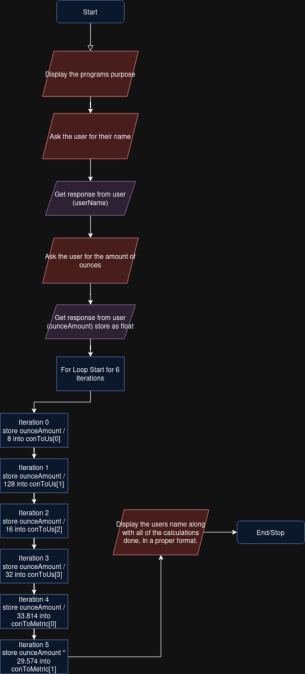

Step 4 Test code, works well.

<https://onlinegdb.com/U1P5uN5IZ>

Step5 Documentation

After you run the code you will be prompted with your name, which will be used to store this data as your own.

Next will be asked how many ounces you would like to convert, this program will convert to all liquid units in the US system and Metric system. You can input half ounces if you would like there is no limit for this.

After you input the amount of ounces you would like converted you will then see your name along with the amount of ounces you converted with all of the conversions listed in a easy to read format.

The name is not necessary, but is helpful if multiple people are using this program and need to be separated.

The process of the program goes in said order,

It will first store your name as a userName, and the ounces as the ounceAmount.

The software will then store all of the conversion into an array that will store 4 float values for the US units and 2 for the metric units that being Cups, Gallon, Pints and Quarts in that order for the US units. Liters and MilLiters for the metric units in the order.

The final step is the software displaying all of the information in a formatted way to the user.